

Sheridan College

Brampton | Mississauga | Oakville

Trafalgar Road Campus, 1430 Trafalgar Road

Oakville, Ontario L6H 2L1

905-845-9430 x8377

[Carol.izzio1@sheridancollege.ca](mailto:Carol.izzio1@sheridancollege.ca) sheridancollege.ca

Dear Recipient,

Sheridan College, in an effort to comply with the *Building Ontario Business Initiatives Act, 2022, S.O. 2022, c. 2, Sched. 2* (“BOBI”), is seeking to identify whether our existing and future vendors qualify as an Ontario Business as defined in legislation under Regulation 422/23.

Based on the definition in Appendix A, Sheridan would ask that you attest to the following statement:

According to the definition put out in BOBI, O. Reg 422/23, [Company Name] is considered an Ontario business. Yes __ No__

I, [Company Rep Name], have the authority to respond to this attestation and therefore bind the organization, [Company Name].

_________________________ __________________ __________________ _________________

Company Rep Signature Position Email Phone #

Please send a signed copy of this back to Sheridan at [purchasing@sheridancollege.ca](mailto:purchasing@sheridancollege.ca) with the email subject line to read – **BOBI Attestation [Company Name]**.

Sheridan requires that this document be returned regardless of your answer to the statement above. If we do not receive a response within 30 days, we will consider your answer to the statement to be “no”.

Reach out anytime with questions.

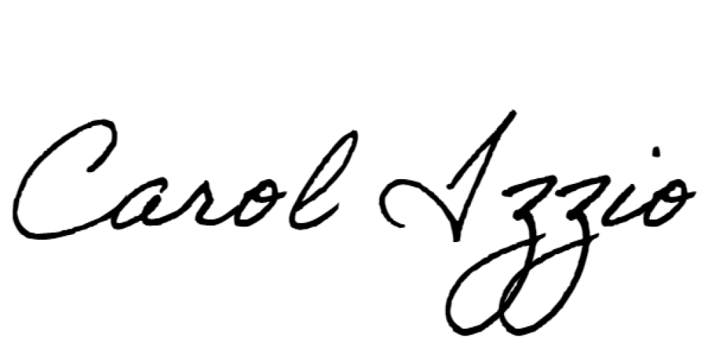Warm regards,

**Carol Izzio (She/her)**

Director, Procurement Business Services

**(365) 292-3457**

[Carol.izzio1@sheridancollege.ca](mailto:Carol.izzio1@sheridancollege.ca)

**Appendix A – BOBI, O. Reg. 422/23: GENERAL [Section 1-7 come into force on April 1, 2024[**

Definitions

1. In this Regulation,

“business structure” includes a sole proprietorship, partnership, corporation or other business structure; (“structure d’entreprise”)

Ontario business

2. (1) A business that meets the following requirements is considered to be an Ontario business for the purposes of the Act:

1. The business is a supplier, manufacturer or distributor of any business structure that conducts its activities on a permanent basis in Ontario.

2. The business either,

i. has its headquarters or main office in Ontario, or

ii. has at least 250 full-time employees in Ontario at the time of the applicable procurement process.

(2) In determining whether a business is considered to be an Ontario business for the purposes of the Act, a public sector entity may rely on a representation by the business that it meets the requirements of subsection (1).

B. Link to full regulation:

<https://www.ontario.ca/laws/regulation/r23422#:~:text=A%20public%20sector%20entity%20is,respect%20of%20the%20procurement%20process>.